BioPad M8 Admin Guide

Version 1.6.19

Contents:
- Overview
- Registering a device that has been reset
- Firmware Update
- Android MAC address fix

Overview
The BioPad M8 (8” screen) devices run Android version 5.1 (lollypop) as the underlying operating system on which the REACH BioPad app then runs. The BioPad app runs as a launcher so replacing the standard interface that Android comes with, this enables the app to control how a user interacts with the device, protecting the settings from unwanted attention and also restricting use to just the BioPad app.
As per most software development there will be regular releases of the BioPad app and very occasionally there will be updates to the device themselves, known as firmware updates, that will provide enhancements or fixes to the device.
Known issues as of June 2019 that the firmware update addresses of previous versions of the BioPad are:
- Flickering Screen
- Uneven lighting of the screen
- WiFi MAC address random allocation
If your BioPad is suffering from any of these conditions, then please update the firmware first.

Registering a Device
Your BioPad device will come with a copy of the Android operating System that is already registered to Google but if you do need to factory reset the device, or after installing any firmware updates, you will need to register the device once more as Android will reset to factory defaults.
For the uncertified device issue, please go to Settings > Apps , then scroll right to the ‘All’ tab and find these three apps in the list:
- Google Play Store
- Google Play Services
- Google Service Framework
Clear the data for all three apps by clicking on the app and then ‘CLEAR DATA’
Once completed, reboot the device.
Once the device has rebooted, go to the browser (the blue planet icon) and download the file ‘deviceid.apk’ from http://aus01.touchline.com.au/bp
Once downloaded install the program, you should then find the icon ‘Device ID’ on the desktop, run it and copy the GSG ID (not the Android Device ID)
Open a browser on your desktop or laptop computer and go to https://www.google.com/android/uncertified/ and enter the GSG ID, restart the device.
It may sometimes take a while for the registered device to be updated by Google, during this time you will not be able to access certain Google services such as the Play Store, if it doesn’t update straight away keep returning and checking.

Firmware Update
How do I know if I need to update the firmware?
If you have a green background to the Android desktop then you need to update the device, if it is a blue background then the device has the latest firmware update (as of June 2019).
What do I need to perform the update?
You will need a PC with USB cable connectivity to the device (USB to Micro USB).
You will need the Firmware_June19.zip file and the BioPad Flash Tool.zip file both of which are downloadable from http://aus01.touchline.com.au/bp - download this onto the PC that you plan to perform the upgrade from, do not download it onto the BioPad.
IMPORTANT
Back up any data from the device as the device will have all data removed during the update process.
Not following this process described below can result in the device being rendered inoperable – if you feel that you are not comfortable with updating the firmware please contact your local REACH office in the first instance.

Process
Once you have downloaded the Firmware_June19.zip file to the PC that you are going to use to perform the upgrade, un zip the downloaded file and open the folder ‘Firmware and document’ that is created.
Unzip system ROM package, it will start with EK-M8_154475….
Download the file BioPad Flash Tool.zip file from https://aus01.touchline.com.au/bp if you haven’t already don so.
Unzip and the files shown after extraction listed as below:
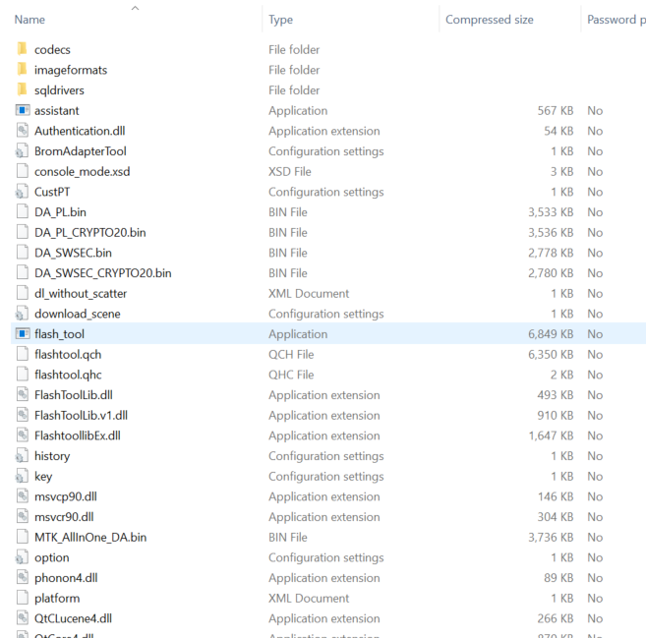

Click on flash_tool.exe and the interface will show as below:
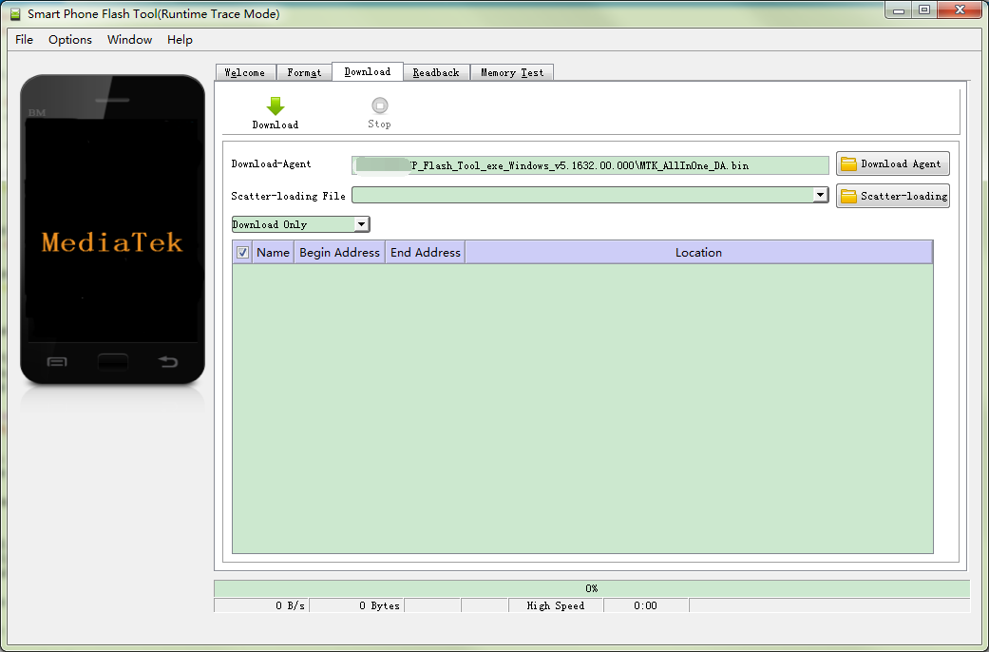

Click Scatter-loading button and choose the directory where you unzipped the system ROM package, double click MT6735_Android_scatter.txt file.
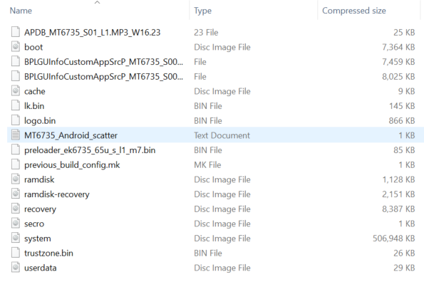
Once the Flash Tool shows that the data is uploaded from the text file as per the picture below, click the Download button.

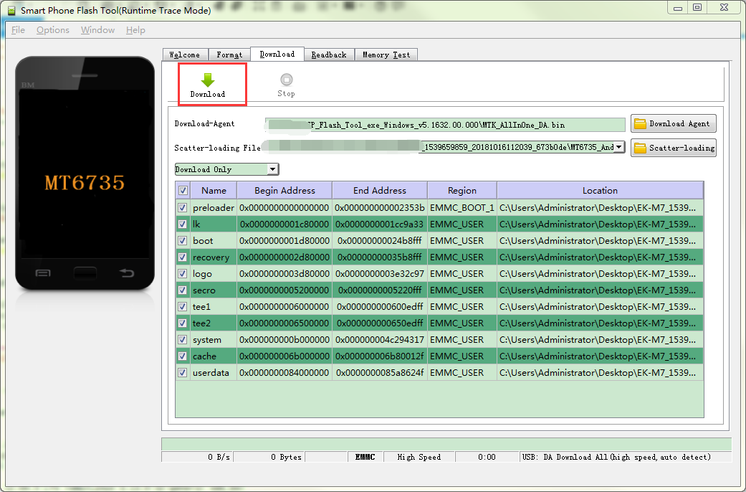

IMPORTANT
Power off the BioPad before connecting any USB cable
Once the BioPad is powered off use the USB cable to connect the device to your PC, wait for the download process to finish, during this process the device will show a blank screen, don’t disconnect the USB cable during downloading (system burn in), the entire process will take around 2-3 minutes.

Once the firmware update is completed successfully, the interface will show a big green tick as below.

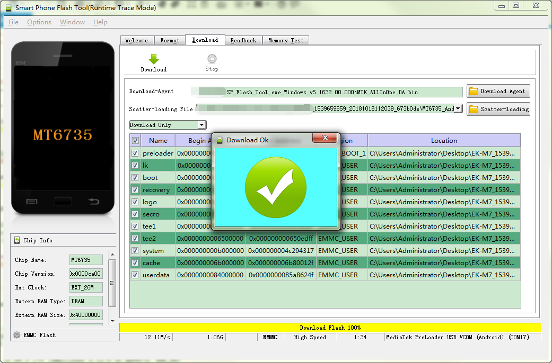

You can now disconnect the USB cable, long press the power button to boot up the device.
If the firmware update has completed successfully you should now have a blue background to the BioPad, you will now have to set the device up again including registering the device with Google (see above) and downloading the BioPad app.
If the device does not power back on after a number of attempts, please contact your local REACH office.
If you have been experiencing issues with the device not maintaining a MAC address upon rebooting the device, please test this out first after updating the firmware as most devices will maintain the MAC address after the update. If the problem persists then please move onto the MAC address fix process.

Android MAC Address fix
Only proceed once you have updated the firmware and if the MAC address has not been fixed by the firmware update. Navigate to the folder where you unzipped the system ROM package earlier, (the one that started EK-M8_154475..), note the 2 files marked below will be used later.
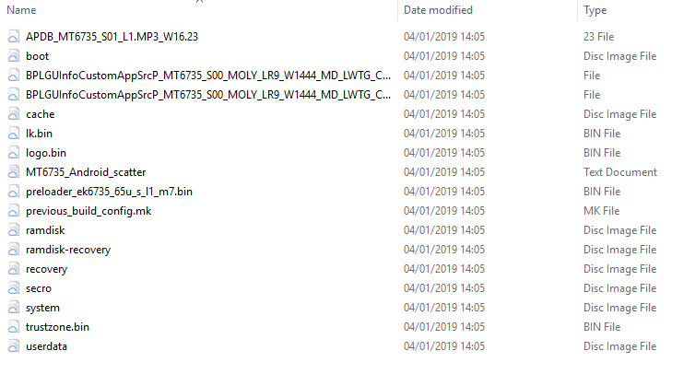
Navigate back to the root of the extracted file and unzip the file SN_Writer_tool_exe_v1.0_1604.00_All_In_One.rar, after extraction there will be two folders, open the Output folder, find SN Writer.exe program and double click to execute.

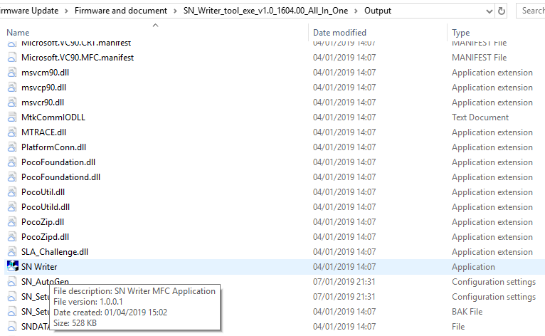

The SN writer will open and show as below, click System Config button.

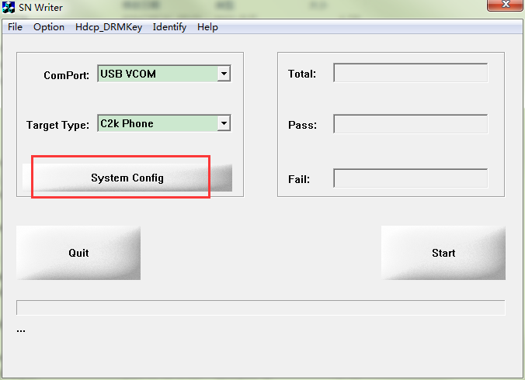
The interface will be shown as picture below, untick Barcode, IMEI, BT Address, and only tick WIFI Address, as per the picture below.

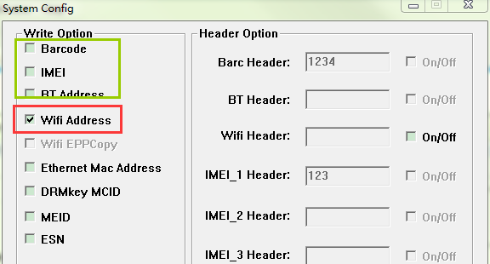

Click the MD1_DB button, and find the route of the unzipped Rom package, and select BPLGUInfoCustomAppSrcP_MT6735_S00_MOLY_LR9_W1444_MD_LWTG_CMCC_MP_V10_P16_1_lwg_n file, click confirm and it will show as per the image below

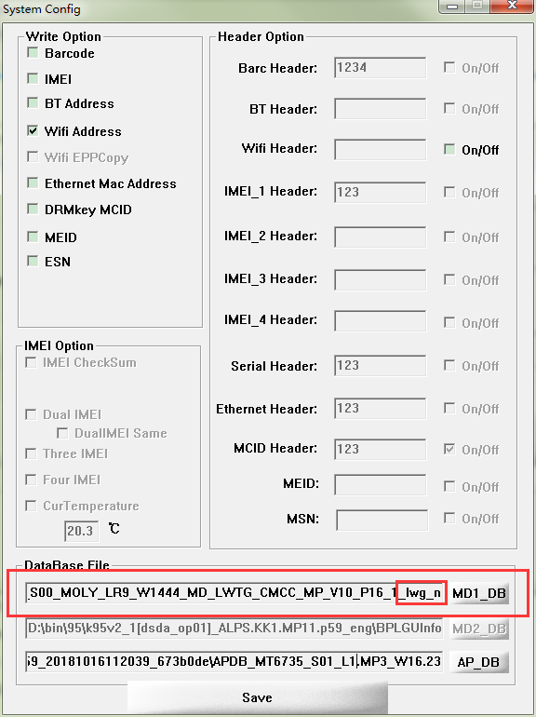

Click AP_DB buttom, select APDB_MT6735_S01_L1.MP3_W16.23 file at the same location as the previous file, select file and click confirm, shown as per the image below

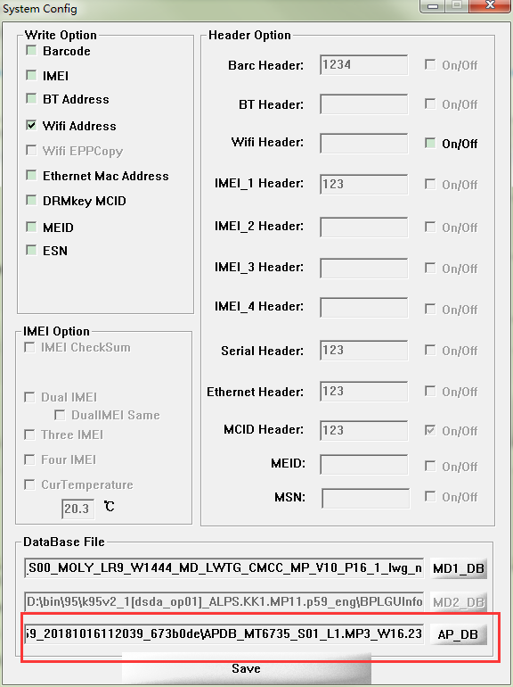
Click save button, exit from current interface and come back to main interface.

Click Start button, and the following dialog box appears, then input the MAC address: 001FFA33210B

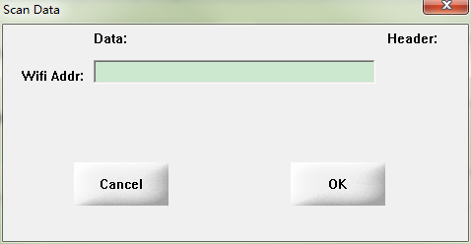

After inputting the MAC address, click OK button, and the dialog box will disappear, now the main interface shows waiting for the device, shown as picture below.

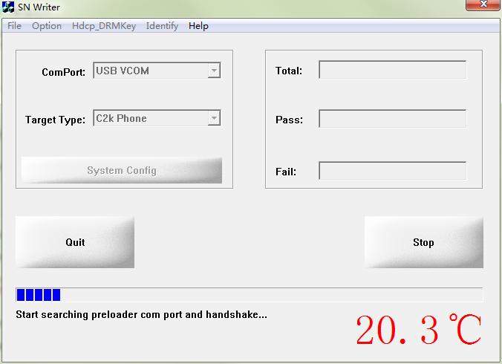

IMPORTANT

Power off the handheld device or tablet, then use USB cable to connect the device to computer, now the device screen will show BioPad boot up logo, and the software will start write in the MAC address, shown as per the picture below.
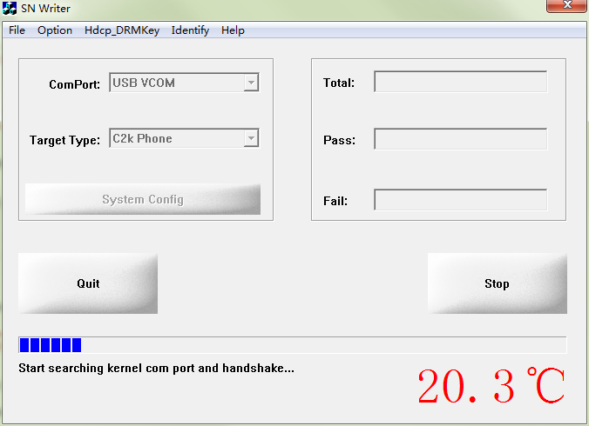
Once the MAC address has written successfully you will get the screen below

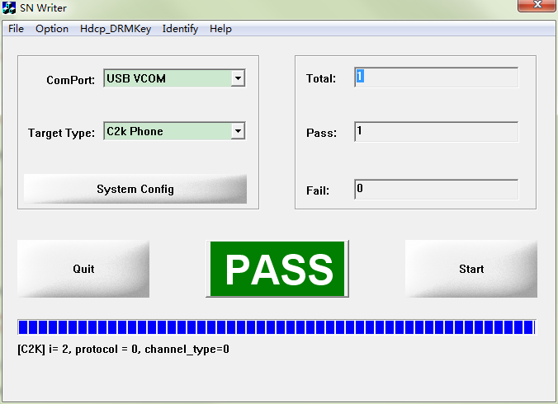
After successfully write in the MAC address, disconnect the USB connection and boot up the device.

